Supplementary Materials
An associative-learning account of infants’ looking in action-efficiency paradigms understanding
ANONYMOUS
Correspondence to: ANONYMOUS

This file includes materials for:
- Simulation 1a: Selective longer looking to inefficient actions.
- Simulation 1b: How prior experience with unconstrained action impacts processing.
- Simulation 2: Independence from animacy.
- Simulation 3: Bidirectional inferences about actions, goals, and constraints.
- Simulation 4: Graded representations of efficiency.
- Simulation 5: Action efficiency understanding in pre-reaching infants.

The aim of this section is to demonstrate that ALIAS’s performance in the main manuscript was robust across different values of the salience learning rate, weight decay, and developmental learning rate. The alternative salience learning rates were 0.0003875 and 0.0004, and the alternative weight decay values were 0.0975 and 0.09875. These values were used throughout the supplementary analyses. Because the range of developmental learning rates differed across simulations, the relevant values are reported separately in each simulation section. Note that all results reported below held across habituation lengths, developmental and salience learning rates, and salience weight decay values.

I. Simulation 1a: Selective longer looking to inefficient actions.

Figure S1. Mean network error produced to the Efficient and Inefficient test events in the Experimental and Control conditions as a function of habituation length, developmental and salience learning rates, and salience weight decay.
The developmental learning rates were 0.0975 and 0.09875. Figure S1 reveals that networks in the Experimental condition produced more error to the Inefficient than to the Efficient test event; networks in the Control condition produced comparable error to both events.

II. Simulation 1b: How prior experience with unconstrained action impacts processing.
The range of parameter values used in this simulation was identical to that in Simulation 1a. Results are reported separately for the two pairs of salience learning rate and weight decay values to facilitate interpretation of the corresponding figures.
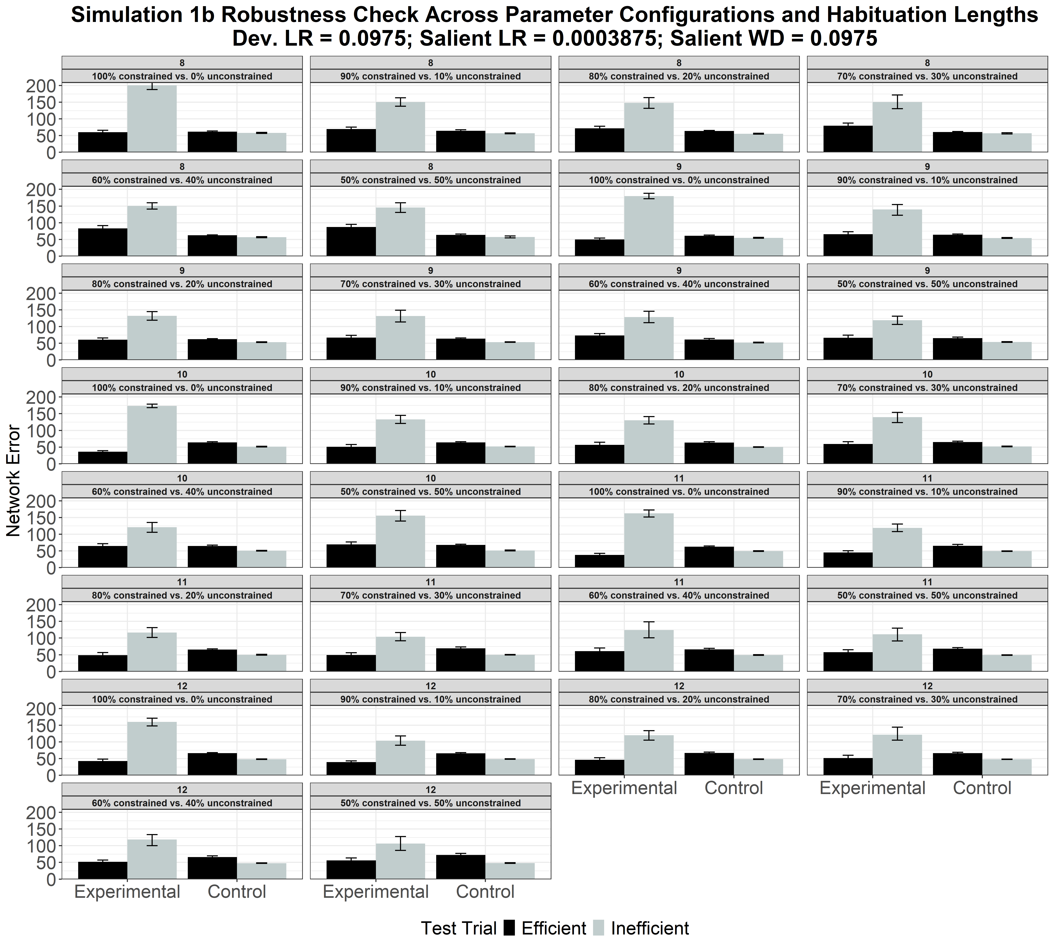
Figure S2. Mean network error produced to the Efficient and Inefficient test events in the Experimental and Control conditions as a function of habituation length and the pretraining ratio of constrained to unconstrained motion events.
Figure S2 shows the results for the model that used a salience learning rate of 0.0003875 and a salience weight decay of 0.0975. This figure shows that, as above, networks in the Experimental condition produced more error to the Inefficient than to the Efficient test event, whereas networks in the Control condition produced comparable error to both test events.

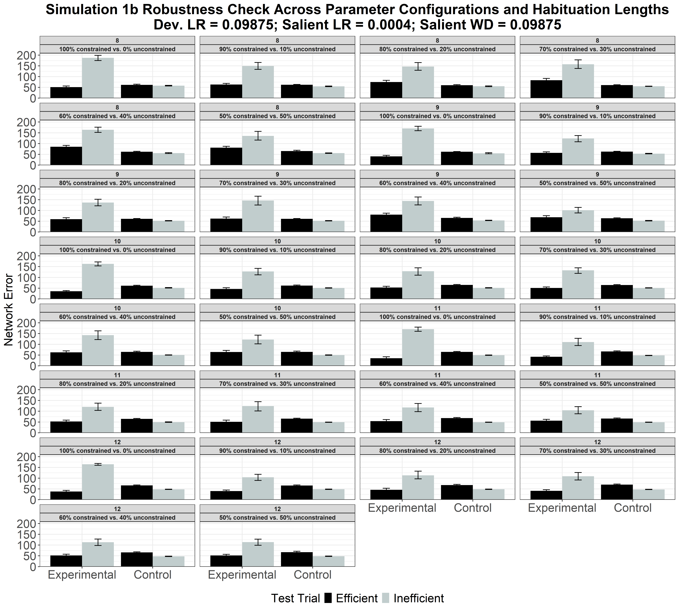
Figure S3. Mean network error produced to the Efficient and Inefficient test events in the Experimental and Control conditions as a function of habituation length and the pretraining ratio of constrained to unconstrained motion events.
Figure S3 depicts the results for the model that used a salience learning rate of 0.0004 and a salience weight decay of 0.09875. Networks in the Experimental condition produced more error to the Inefficient than to the Efficient test event; networks in the Control condition produced comparable error to both test events.

III. Simulation 2: Independence from animacy.

Figure S4. Mean network error produced to the Efficient and Inefficient test events in the Experimental and Control conditions as a function of habituation length, developmental and salience learning rates, and salience weight decay.
The developmental learning rates were 0.08625 and 0.0875. The results depicted in Figure S4 indicate that networks in the Experimental condition produced greater error to the Inefficient than to the Efficient test event; networks in the Control condition produced comparable error to both events.
IV. Simulation 3: Bidirectional inferences about actions, goals, and constraints.

Figure S5. Performance of ALIAS in the Inferring Constraints condition. Mean network error produced to the No-Obstacle and Obstacle test events as a function of habituation length, developmental and salience learning rates, and salience weight decay.
The developmental learning rates were identical to those in Simulation 1. As depicted in Figure S5, networks in the Inferring Constraints condition produced more error to the No-Obstacle than to the Obstacle test event.

Figure S6. Performance of ALIAS in the Inferring Goals condition. Mean network error produced to the Congruent and Incongruent test events as a function of habituation length, developmental and salience learning rates, and salience weight decay.
Figure S6 demonstrates that networks in the Inferring Goals condition produced more error to the Incongruent than to the Congruent test event.

V. Simulation 4: Graded representations of efficiency.

Figure S7. Mean network error produced to the High, inefficient and Low, efficient test events across experiments and as a function of habituation length, developmental and salience learning rates, and salience weight decay.
The developmental learning rates were identical to those in Simulation 2. Figure S7 indicates that networks in Experiments 1 and 3 produced more error to the High, inefficient than to the Low, efficient test event. Networks in Experiment 2 produced numerically more error to the Low, efficient than to the High, inefficient test event.

VI. Simulation 5: Action efficiency understanding in pre-reaching infants.


Figure S8. Performance of networks in the Effective Action condition. Networks’ mean error to the Efficient and Inefficient test events in the Experimental and Control conditions, shown in the top and bottom rows, across different habituation lengths, developmental and salience learning rates, and salience weight decay values.
The developmental learning rates were 0.00875 and 0.01. Figure S8 shows that networks in the Experimental condition produced more error to the Inefficient than to the Efficient test event, whereas networks in the Control condition produced about equivalent error to both events.
Both results were for networks in the Effective Action condition.

Figure S9. Performance of networks in the Ineffective Action condition. Shown is the networks’ mean error to the Efficient and Inefficient test events across different habituation lengths, developmental and salience learning rates, and salience weight decay values.

Figure S9 shows that networks in the Ineffective Action condition produced roughly equivalent error to the Efficient and Inefficient test events.



Figure S10. Performance of networks in the No Training condition. Networks’ mean error to the Efficient and Inefficient test events in the Experimental and Control conditions, shown in the top and bottom rows, across different habituation lengths, developmental and salience learning rates, and salience weight decay values.
Figure S10 indicates that networks in the No Training condition produced approximately equivalent error to the Inefficient and Efficient test events.

Conclusion
Considered together, these qualitative analyses indicate that the results reported in the main paper did not depend on any specific parameter values.

